Ideation Phase
Brainstorm & Idea Prioritization Template
Date | 18 February 2026
Team ID | LTVIP2026TMIDS24123
Project Name | Civil Engineering Insight Studio
Maximum Marks | 4Marks

Brainstorm & Idea Prioritization Template:

Step-1: Team Gathering, Collaboration & Selected Problem Statement

Team Collaboration Summary
- Conducted a structured brainstorming session
- Reviewed PS-1 and PS-2
- Identified common challenges:
  - Manual documentation
  - Time consumption
  - Inconsistent reporting
  - Lack of automation
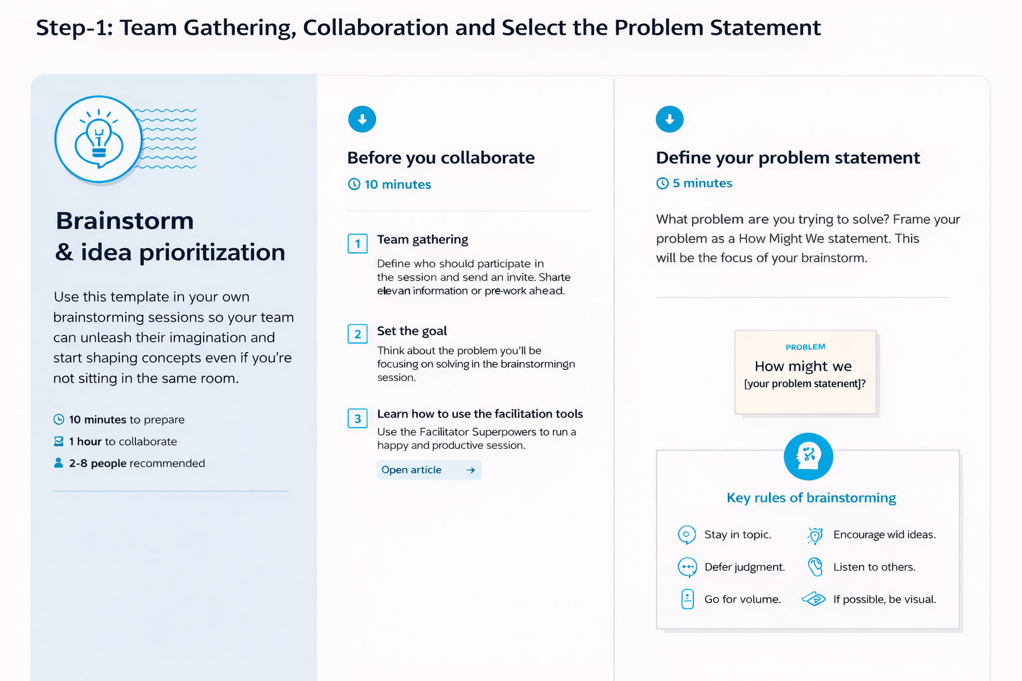

Selected Core Problem Statement
Civil engineers and project managers need an intelligent system that can automatically analyze construction site images and generate structured, consistent documentation to reduce manual effort, save time, and improve reporting accuracy.

Step-2: Brainstorm – Idea Listing & Grouping

Raw Ideas Generated
Idea ID | Idea Description
I1 | AI-based image recognition for material detection
I2 | Automated structural component identification
I3 | Progress percentage estimation from site images
I4 | Auto-generated technical report in PDF format
I5 | Mobile application for real-time site image upload
I6 | Dashboard for project progress visualization
I7 | Voice-to-text reporting integration
I8 | Defect detection and safety risk alerts
I9 | Cloud-based documentation storage
I10 | Standardized report templates with auto-fill functionality

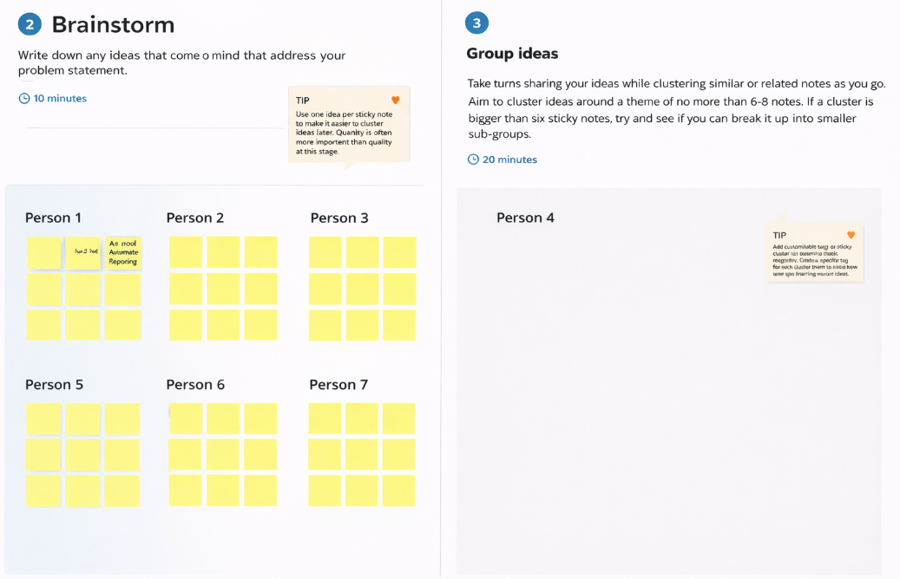

Idea Grouping
Category | Related Ideas
Image Analysis | I1, I2, I3, I8
Report Automation | I4, I10
User Interface & Access | I5, I6
Data Management | I9
Smart Assistance | I7

Step-3: Idea Prioritization

Prioritization Criteria
- Feasibility
- Impact
- Innovation
- Implementation Time
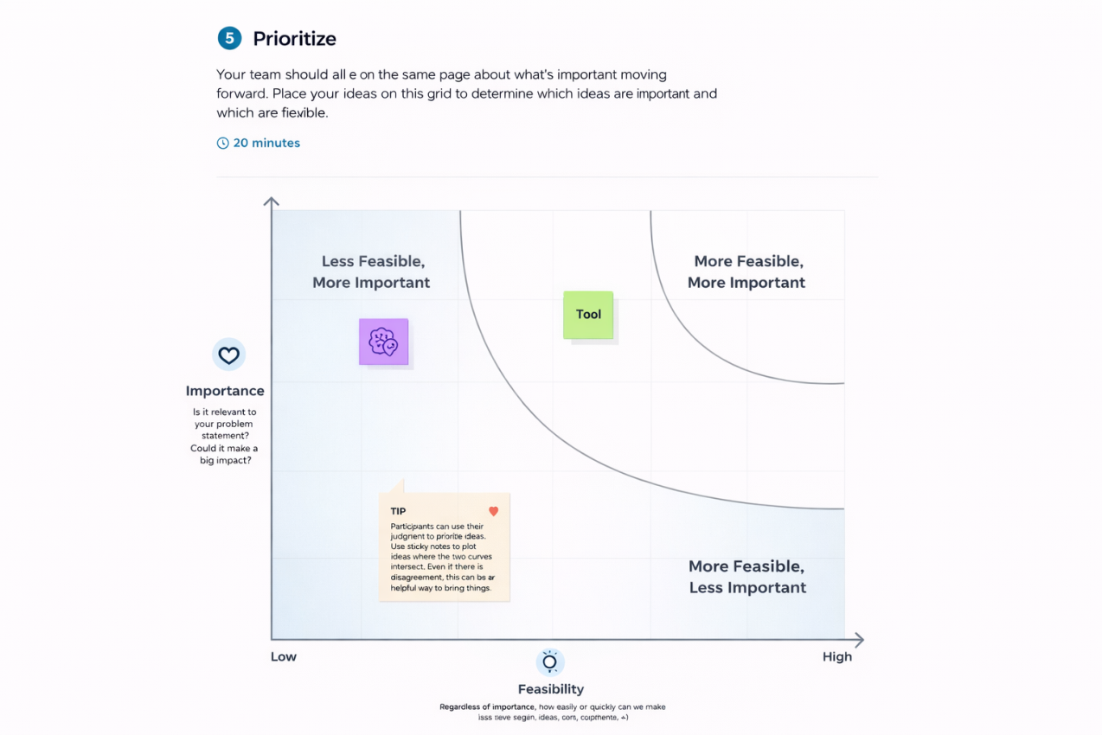

Priority Matrix
Idea | Impact | Feasibility | Priority Level
AI-based image recognition (I1) | High | High | High
Auto-report generation (I4) | High | High | High
Progress estimation (I3) | High | Medium | Medium
Dashboard visualization (I6) | Medium | High | Medium
Defect detection (I8) | High | Medium | Medium
Voice reporting (I7) | Medium | Medium | Low

